Three Threads Application Design
Module 8 Programming Assignment
Author: Zachary White
Professor: Darrell Payne
Course: CSD 420 Advanced Java Programming
Date: September 17th 2026

1. Overview
This application demonstrates multithreading in JavaFX. Three threads run at the same time, and each one generates 10,000 characters of its own type: lowercase letters, digits, and special characters. Every character is added to a shared text area the moment it is generated, so the three types appear mixed together instead of in separate blocks.
The window has a Start button to begin a run, a Clear button to reset the screen, and live counters that show how many characters each thread has produced.
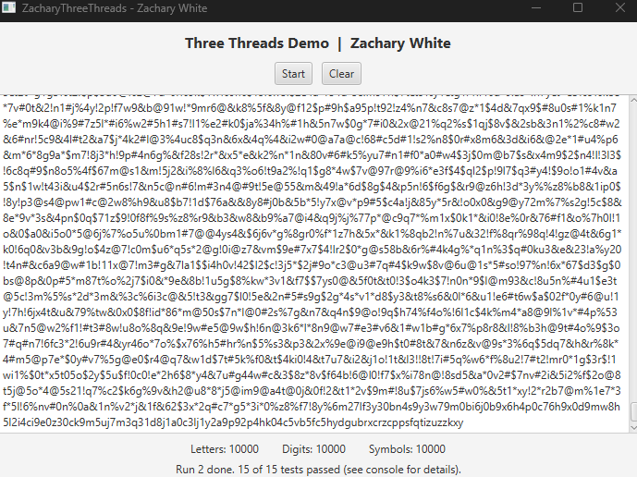
Figure 1. The application window after a completed run

2. Application File
The whole program is contained in one file, ZacharyThreeThreads.java. The class extends javafx.application.Application, and the file name and class name follow the assignment's first-name-plus-ThreeThreads naming rule.

3. Character Generation
Each character type has its own static generator method, and each one uses a different technique to produce a random character.
Type | Method | Technique
Letters | generateLetter() | Adds a random offset (0 to 25) to the ASCII value of 'a' using java.util.Random
Digits | generateDigit() | Converts a random number (0 to 9) into a digit using Character.forDigit() with ThreadLocalRandom
Symbols | generateSymbol() | Picks a random index into a char[] of ! @ # $ % & * using Math.random()

Keeping each generator in its own method makes the threads simple. A thread only needs to be handed the method it should call, and the methods can be tested on their own before any thread starts.

4. Program Design
The program is organized into a few pieces that work together.
- User interface. The start method builds the window with a BorderPane. The top holds the title and the Start and Clear buttons, the center holds a read-only TextArea, and the bottom holds the three live counter labels and a status message.
- Producer task. CharacterProducer is a Runnable that receives a generator method and a counter. Its run method loops 10,000 times, generating one character per pass.
- Starting a run. When Start is pressed, startRun clears the old output, disables both buttons, starts the counter refresh timer, and launches three threads named LetterThread, DigitThread, and SymbolThread.
- Live counters. A Timeline refreshes the three labels about 20 times per second by reading the current counter values.
- Finishing a run. A helper thread waits for all three producers to finish, then schedules the output tests on the JavaFX thread. The timer stops, the buttons are re-enabled, and the status label reports the test results.
- Clear button. resetRun empties the TextArea, sets all counters to zero, and refreshes the labels. It is also called at the start of every run so each run begins clean and with a new number assigned (run 2).

5. Threading Design
Several choices keep the threads working correctly together.
- Platform.runLater. JavaFX controls can only be changed on the JavaFX Application Thread. After generating a character, each producer thread hands the append operation to that thread with Platform.runLater instead of touching the TextArea directly.
- AtomicInteger counters. Each producer increments its own AtomicInteger, which is safe to update from one thread and read from another without extra locking.
- One-millisecond delay. Each producer pauses for 1 ms after every character. Without the pause, one thread could finish before the others got started, and the output would look grouped. The delay lets the threads take turns so the mixing is clearly visible.
- Helper thread with join. The waiting is done on a separate thread so the JavaFX thread never blocks. Its final runLater call goes to the back of the event queue, so every character append has already happened before the output tests read the TextArea.
- Disabled buttons during a run. Start and Clear are disabled while threads are running, which prevents a second run from starting or the text from being cleared mid-run.

6. Test Design
The program has 15 built-in tests that print PASSED or FAILED to the console. They run in three groups at different points in the program.
- Generator tests (1 to 7) run once at launch. Each generator is called 10,000 times to confirm every result is valid and that every possible character appears.
- Control tests (8 and 9) run once at launch. They check the button states, then fill the TextArea and counters with dummy data and call resetRun to confirm the Clear logic works.
- Output tests (10 to 15) run at the end of every run. They inspect the finished TextArea, the counters, the labels, and the buttons.

Test | Group | What It Verifies
1 | Generator | generateLetter() only returns letters a-z
2 | Generator | generateLetter() produced all 26 letters over 10,000 calls
3 | Generator | generateDigit() only returns digits 0-9
4 | Generator | generateDigit() produced all 10 digits over 10,000 calls
5 | Generator | generateSymbol() only returns the allowed symbols
6 | Generator | generateSymbol() produced all 7 symbols over 10,000 calls
7 | Generator | Each thread is set to produce at least 10,000 characters
8 | Control | Start and Clear buttons are enabled before a run
9 | Control | Clear empties the TextArea and resets all counters and labels
10 | Output | Each thread's counter reached 10,000
11 | Output | TextArea holds 30,000 characters in total
12 | Output | TextArea has 10,000 of each character type
13 | Output | Output is mixed, not grouped (more than 100 type changes)
14 | Output | Live counter labels show the final totals
15 | Output | Start and Clear buttons are enabled again after the run

Test 13 confirms the requirement that the data is not displayed grouped by thread. It counts how many times the character type changes from one character to the next. A fully grouped output would have only two changes, while the runs shown below had over 28,000.

7. Test Results
The program was compiled and run from the command line. The console shows the generator and control tests once, followed by the output tests for two separate runs. All 15 tests passed each time, and the window's status label also reports 15 of 15 tests passed for run 2.
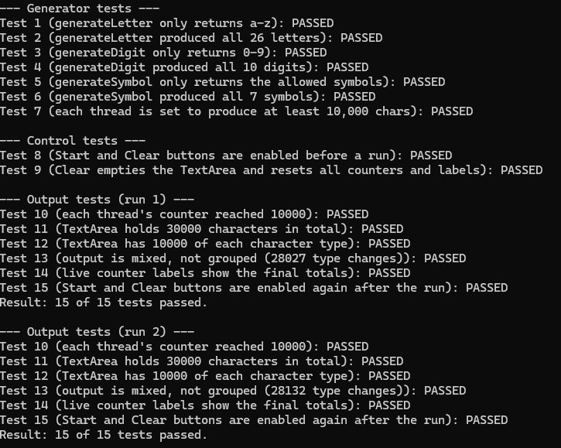
Figure 2. Console output showing all tests passing for two runs

8. Compile and Run
The program is compiled and run with the JavaFX SDK on the module path:
javac --module-path %PATH_TO_FX% --add-modules javafx.controls ZacharyThreeThreads.java
java --module-path %PATH_TO_FX% --add-modules javafx.controls ZacharyThreeThreads.java
After the window opens, press Start to begin a run and Clear to reset the screen once it finishes.

9. Conclusion
This assignment showed how several threads can work at the same time and share one user interface safely. Platform.runLater keeps the TextArea updates on the JavaFX thread, atomic counters let the threads report progress without locking, and a small delay makes the interleaving easy to see. The built-in tests confirmed that each generator produces valid characters, each thread produced exactly 10,000, and the output was mixed rather than grouped.

10. References
Jenkov, J. (2024). Java concurrency and multithreading tutorial. https://jenkov.com/tutorials/java-concurrency/index.html
Liang, Y. D. (2024). Introduction to Java programming and data structures (13th ed.). Pearson.
Oracle. (n.d.-a). AtomicInteger (Java Platform SE 8). https://docs.oracle.com/javase/8/docs/api/java/util/concurrent/atomic/AtomicInteger.html
Oracle. (n.d.-b). Character (Java Platform SE 8). https://docs.oracle.com/javase/8/docs/api/java/lang/Character.html
Oracle. (n.d.-c). Concurrency (The Java Tutorials). https://docs.oracle.com/javase/tutorial/essential/concurrency/
Oracle. (n.d.-d). Platform (JavaFX 8). https://docs.oracle.com/javase/8/javafx/api/javafx/application/Platform.html
Oracle. (n.d.-e). ThreadLocalRandom (Java Platform SE 8). https://docs.oracle.com/javase/8/docs/api/java/util/concurrent/ThreadLocalRandom.html
Oracle. (n.d.-f). Timeline (JavaFX 8). https://docs.oracle.com/javase/8/javafx/api/javafx/animation/Timeline.html

